**VISVESVARAYA TECHNOLOGICAL UNIVERSITY**



MINI PROJECT REPORT ON

**“SIMULATION OF RECTANGULAR MICROSTRIP PATCH ANTENNA”**

SUBMITTED BY:

**Rohit M (1NH18EC062)**

**ROHAN S PATIL (1NH18EC097)**

**RUPENDRAN A M(1NH18EC138)**

**RAVI N (1NH18EC141)**

Under the guidance of

**MR.ARAVINDA K**

Senior Assistant Professor, Dept. of ECE, NHCE, Bengaluru.

# C:\Documents and Settings\Students\Local Settings\Temporary Internet Files\Content.Word\download (1).jpg

# NEW HORIZON COLLEGE OF ENGINEERING

(ISO-9001:2000 certified, Accredited by NAAC ‘A’, Autonomous college permanently affiliated to VTU)Outer Ring Road, Panathur Post, Near Marathalli, Bengaluru-560103

## NEW HORIZON COLLEGE OF ENGINEERING

## DEPARTMENT OF ELECTRONICS AND COMMUNICATION ENGINEERING



**CERTIFICATE**

Certified that the mini project work entitled “**SIMULATION OF RECTANGULAR MICROSTRIP PATCH ANTENNA**” carried out by **ROHIT M(1NH18EC062), ROHAN S PATIL (1NH18EC097), RUPENDRAN A M (1NH18EC138), RAVI N (1NH18EC141)** bonafide students of Electronics and Communication Department, New Horizon College of Engineering, Bangalore.

The mini project report has been approved as it satisfies the academic requirements in respect of mini project work prescribed for the said degree.

Project Guide HOD ECE

MR. ARAVINDA K

------------------------- -------------------------

**External Viva**

Name of Examiner Signature with Date

1.

2.

**ACKNOWLEDGEMENT**

The satisfaction that accompany the successful completion of any task would be, but impossible without the mention of the people who made it possible, whose constant guidance and encouragement helped us succeed.

We thank **Dr. Mohan Manghnani**, Chairman of **New Horizon Educational Institution**, for providing necessary infrastructure and creating good environment.

We also record here the constant encouragement and facilities extended to us by **Dr.Manjunatha**, Principal, NHCE and **Dr. Sanjeev Sharma**, head of the department of Electronics and Communication Engineering. We extend sincere gratitude to them.

We sincerely acknowledge the encouragement, timely help and guidance to us by our beloved guide **MR. ARAVINDA K** to complete the project within stipulated time successfully.

Finally, a note of thanks to the teaching and non-teaching staff of electronics and communication department for their co-operation extended to us, who helped us directly or indirectly in this successful completion of mini project.

**Rohit M (1NH18EC062)**

**ROHAN S PATIL (1NH18EC097)**

**RUPENDRAN A M(1NH18EC138)**

**RAVI N (1NH18EC141)**

**TABLE OF CONTENTS**

ABSTRACT

**CHAPTER 1**

INTRODUCTION…………………………………………………………………………………8

**CHAPTER 2**

LITERATURE SURVEY………………………………………………………………………… 11

**CHAPTER 3**

PROPOSED METHODOLOGY…………………………………………………………………..12

**CHAPTER 4**

PROJECT DESCRIPTION ………………………………………………………………………..

4.1 HARDWARE DESCRIPTION……………………………………………………………….15

4.2 SOFTWARE DESCRIPTION…………………………………………………………………16

**CHAPTER 5**

RESULTS AND DISCUSSION…………………………………………………………………20

**CHAPTER 6**

CONCLUSION AND FUTURE SCOPE …………………………………………………………24

REFERENCES…………………………………………………………………………………….27

APPENDIX………………………………………………………………………………………..28

**LIST OF FIGURES**

|  |  |  |  |
| --- | --- | --- | --- |
| **SL**  **No** | **FIGURE**  **No** | **FIGURE DESCRIPTION** | **Page**  **No** |
| 1 | 1.1 | Microstrip patch antenna | 9 |
| 2 | 1.2 | Common shapes for radiating patch. | 10 |
| 3 | 3.1 | Block Diagram of microstrip patch antenna | 12 |
| 4 | 3.2 | transmission line model | 13 |
| 5 | 4.1 | Coexial probe feed p | 17 |
| 7 | 4.2 | Microstrip line feed patch antenna | 17 |
| 8 | 4.3 | Aperture couple feed patch antenna | 18 |
| 9 | 4.4 | Proximity couple microstrip patch antenna | 18 |
| 10 | 5.1 | Output 1 | 19 |
| 11 | 5.2 | Output 2 | 20 |
| 12 | 6.1 | Flow chart for transmission line model | 29 |

### LIST OF TABLES

|  |  |  |  |
| --- | --- | --- | --- |
| **SL**  **No** | **Table**  **No** | **TABLE DESCRIPTION** | **Page**  **No** |
| 1 | 1.1 | Literature review | 32 |
|  |  |  |  |

**ABSTRACT**

Simulation of a rectangular microstrip patch antenna on MATLAB platform is presented in form of three algorithms. The design algorithm which computes the dimensions of the rectangular microstrip patch antenna is based on the transmission line model. The cavity model algorithm analysis the rectangular microstrip patch antenna. The radiation pattern algorithm plots the radiation patterns of the antenna. The algorithms developed were used to model and simulate three different specifications of rectangular patch antenna. The results obtained are found to compare favorably with existing records.

The project we are doing in this paper is transmission line model using MATLAB R2015a. this paper presents the design and simulation of rectangular patch antenna using MATLAB software by using Simulink and antenna toolbox .The paper aims that a very short document on history of development of antennas for wireless communication systems, trends in antenna technology ,merits and demerits of micro strip patch antenna various aspects are all in the introduction section. The paper highlights the design aspects of rectangular microstrip patch antenna, the coding and the results of the designed microstrip patch antenna.

**Keywords**: List of Keywords

Antenna

Microstrip patch

Transmission line model

Cavity model

Radiation pattern

Matlab

Dielectric constant

Substrate thickness

Frequency

Input impedance

CHAPTER -1

INTRODUCTION

Antenna

In general an antenna is a part of transmitting or receiving system that can transmit or receive electromagnetic waves. There are different kinds of antenna that used in several applications. Some of them are: wire antenna, aperture antenna, printed antenna, array antenna, reflector antenna, and lens antenna. Among these antennas printed antenna is fabricated using photolithography technique. Most common version of the printed antenna is micro strip antenna. It is constructed using conventional micro strip fabrication technique. Micro strip antenna consists of a radiating patch on one side of a dielectric substrate and has a ground plane on the other side.

Microstrip Patch Antenna

In telecommunication, a micro strip antenna also known as a printed antenna usually means an antenna fabricated using micro strip techniques on a printed circuit board (PCB). It is a kind of internal antenna. They are mostly used at microwave frequencies. An individual micro strip antenna consists of a patch of metal foil of various shapes of patch antenna on the surface of a PCB with a metal foil ground plane on the other side of the board. Most micro strip antennas consist of multiple patches in a two-dimensional array. The antenna is usually connected to the transmitter or receiver through foil micro strip transmission lines. The radio frequency current is applied or in receiving antennas the received signal is produced between the antenna and ground plane.

Micro strip patch antenna is one kind of micro strip antenna and it is most widely chosen among other kinds because of its different shapes. In micro strip patch antenna (MSPA), the patch is generally made of a conducting material such as copper or gold. The micro strip patch antenna can have any shape but, rectangular, circular, triangular and elliptical are some common shapes. The radiating patch and the feed lines are usually photo-etched on the dielectric substrate.

 Common micro strip antenna shapes are square, rectangular, circular and elliptical, but any continuous shape is possible. Some patch antennas do not use a dielectric substrate and instead are made of a metal patch mounted above a ground plane using dielectric spacers; the resulting structure is less rugged but has a wider bandwidth.

Microstrip antenna technology began its rapid development in the late 1970s. By the early 1980s, primary microstrip antenna elements and arrays were relatively well established in terms of design and modeling. Microstrip antennas have received a lot of attention because of their many advantages. These advantages include low profile, low cost, conformability to planar and non-planar surfaces and ease of integration with active devices. The microstrip patch antenna consists of three basic parts; the radiating patch, the dielectric substrate and the ground plane as illustrated. The dielectric substrate is located between the radiating patch and the ground plane. The radiating patch is made of any conducting material and it can take up any shape depending on the design requirements. Some of the most common shapes of radiating patch. The ground plane is a metal plate bonded to one side of the dielectric substrate.

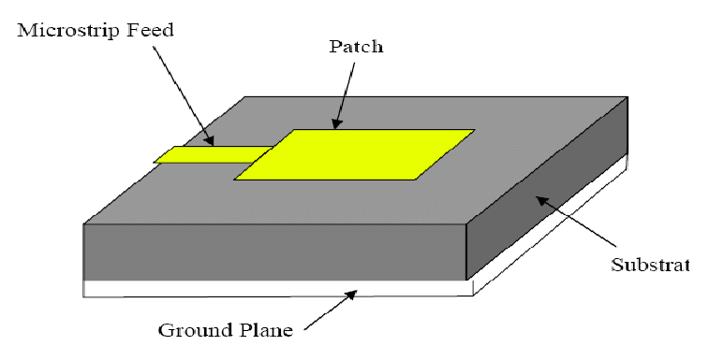

Figure 1.1: Microstrip patch antenna.

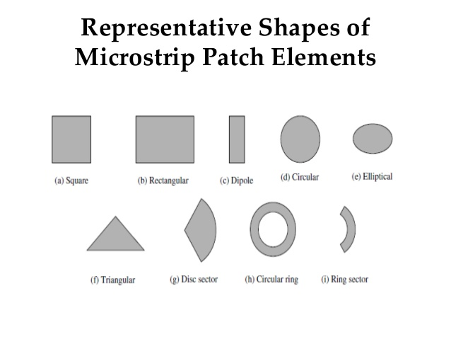

Figure1. 2: Common shapes for radiating patch.

Simulation using Matlab

It is necessary to predict exactly how an antenna will behave prior to actual fabrication. Modelling and simulation predict the radiation characteristics of an antenna and suggest necessary modifications before fabrication. There are currently several full electromagnetic modelling tools and products such as Ansoft Ensemble, High Frequency Structure Simulation (HFSS) and Computer Simulation Technology and Microwave Studio (CST MS) that are used in the modelling and simulation of complex circuits and antennas. However, a lot of these softwares come at a very steep price and are sometimes proprietary. It is possible to implement the modelling and simulation entirely on MATLAB platform and this makes it much more accessible and affordable to students and designers. MATLAB is a ubiquitous math, data manipulation, signal processing, and graphics software package. It can be used effectively in the design and analysis of antenna. In this work, modelling and simulation of a rectangular microstrip antenna are implemented in MATLAB working environment.

CHAPTER -2

**Literature Survey**

In the recent years the development in communication systems requires the development of low cost, minimal weight, low profile antennas that are capable of maintaining high performance over a wide spectrum of frequency. This technological trend has focused much effort into the design of a Microstrip patch antenna. However, the difficult of antenna design increases when the number of operating frequency band increase. In additional, for miniaturization the wireless communication system, the antenna must also be small enough to be placed inside the system. In order to transmit and receive more information large bandwidth are required, and bandwidth enhancement is currently a popular research area. The aim of this thesis is to design a rectangular microstrip path antenna for global WLAN systems and study the effect of various antenna parameters such as the performance of the antenna in term of radiation pattern Directivity, gain, bandwidth, VSWR, return loss and, far-field etc. here line feed method was used to exited the patch antenna. The First antenna was designed to operate at a resonant frequency of 2.45GHz dielectric substrate (Rogers RT5870) with relative permittivity (=2.33) and thickness of 0.787mm, for applications such as IEEE 802.11 Wi-Fi, IEEE 802.15.1 Bluetooth, IEEE 802.15.4 ZigBee, wireless USB, microwave oven, codeless phone etc. The proposed antennas have been design using Matlab, modeled and simulated by using computer simulation technology (CST) micro studio. The simulation results of designed antennas indicate that the proposed antenna fulfils the excellent requirements and characteristics for various frequency bands and showing the good radiation patterns and characteristics in the interested WLAN communication.

|  |  |  |  |
| --- | --- | --- | --- |
| **Title of the paper** | **Author & Year of Publication** | **Outcome** | **Limitation** |
| **Antenna theory** | Constantine A . balanis | The formulas we have used was taken from this book | There is no code in this book for reference |

CHAPTER -3

**Proposed Methodology**

**Block Diagram**

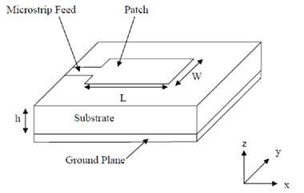

Figure 3.1: Block Diagram of microstrip patch antenna

**TRANSMISSION LINE MODEL:**

Transmission Line Model. W is the width of the patch, L is the actual length of the patch, wo is the width of the feed and 𝜖𝑟 is the dielectric constant of the substrate. h is the distance between the patch and the ground plane which may represent the thickness of the substrate. The fringing effect comes into play as the dimensions of the radiating patch are finite and the fields at the edge undergo fringing . Fringing makes the microstrip look wider electrically compared to its physical dimensions and since some of the waves travel in the substrate and some in air, an effective dielectric constant 𝜖𝑟𝑒𝑓𝑓 is introduced to account for this fringing effect and the wave propagation in the line.

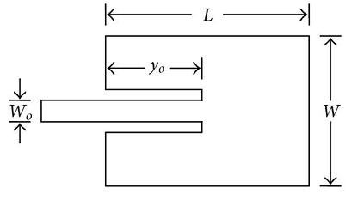

Figure: 3.2 transmission line model

**CHAPTER -4**

**Project Description**

**Software Description**

MATLAB R2015a:

MATLAB is a high-performance language for technical computing. It integrates computation, visualization, and environment where problems and solutions are expressed in familiar mathematical notation.

* We are using MATLAB software for processing a rectangular microstrip patch antenna .
* The version that we are using is R2015a .
* MATLAB is a high-performance language for technical computing.
* It integrates computation, visualization, and programming in an easy to use environment where problems and solutions are expressed in mathematical notation.

**Uses of MATLAB**

* Math and computation
* Algorithm development
* Modeling, simulation, and prototyping
* Data analysis, exploration, and visualization
* Scientific and engineering graphics
* Application development, including Graphical User Interface building

**Hardware Description**

We do not use any hardware components in this project. But here, we are explainingthe feeding technique in to the microstrip patch antenna.

A microstrip patch antenna (MPA) consists of a conducting patch of any planar or nonplanar geometry on one side of a dielectric substrate with a ground plane on other side. It is a popular printed resonant antenna for narrow-band microwave wireless links that require semi-hemispherical coverage. Due to its planar configuration and ease of integration with microstrip technology, the microstrip patch antenna has been heavily studied and is often used as elements for an array. A large number of microstrip patch antennas have been studied to date. An exhaustive list of the geometries along with their salient features is available . The rectangular and circular patches are the basic and most commonly used microstrip antennas. These patches are used for the simplest and the most demanding applications. Rectangular geometries are separable in nature and their analysis is also simple. The circular patch antenna has the advantage of their radiation pattern being symmetric.

**Feeding Techniques :**

A feedline is used to excite to radiate by direct or indirect contact. There are many different techniques of feeding and four most popular techniques are coaxial probe feed, microstrip line, aperture coupling and proximity coupling .

Coaxial probe feeding is feeding method in which that the inner conductor of the coaxial is attached to the radiation patch of the antenna while the outer conductor is connected to the ground plane. Advantages of coaxial feeding is easy of fabrication, easy to match, low spurious radiation and its disadvantages is narrow bandwidth, Difficult to model specially for thick substrate.

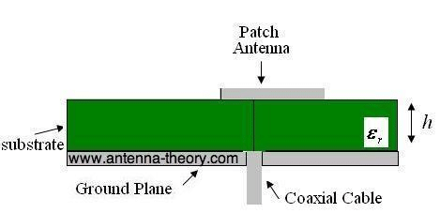

Figure 4.1: Coexial probe feed p

Microstrip line feed is one of the easier methods to fabricate as it is a just conducting strip connecting to the patch and therefore can be consider as extension of patch. It is simple to model and easy to match by controlling the inset position. However the disadvantage of this method is that as substrate thickness increases, surface wave and spurious feed radiation increases which limit the bandwidth.

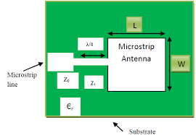

Figure 4.2: Microstrip line feed patch antenna

Aperture coupled feed consist of two different substrates separated by a ground plane. On the bottom side of lower substrate there is a microstrip feed line whose energy is coupled to the patch through a slot on the ground plane separating two substrates. This arrangement allows independent optimization of the feed mechanism and the radiating element. Normally top substrate uses a thick low dielectric constant substrate while for the bottom substrate; it is the high dielectric substrate. The ground plane, which is in the middle, isolates the feed from radiation element and minimizes interference of spurious radiation for pattern formation and polarization purity. Advantages is allows independent optimization of feed mechanism element.

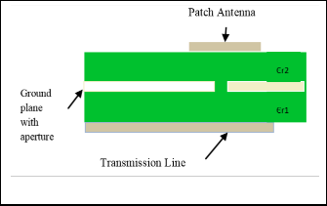

Figure 4.3: Aperture couple feed patch antenna

Proximity coupling has the largest bandwidth, has low spurious radiation. However fabrication is difficult. Length of feeding stub and width-to-length ratio of patch is used to control the match. Its coupling mechanism is capacitive in nature.

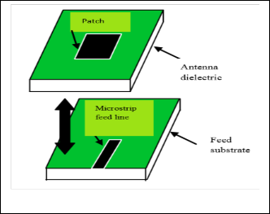

Figure 4.4: Proximity couple microstrip patch antenna

The major disadvantage of this feeding technique is that it is difficult to fabricate because of the two dielectric layers that need proper alignment. Also there is increase in overall thickness of the antenna.

In the wide range of antenna models there are different structures of Microstrip antennas, but on the whole we have four basic parts in the antenna : They are:

-The patch

- Dielectric Substrate

- Ground Plane

- Feed Line

**CHAPTER -5**

**Result:**

**Snapshot of our output:**

Figure 5.1: output 1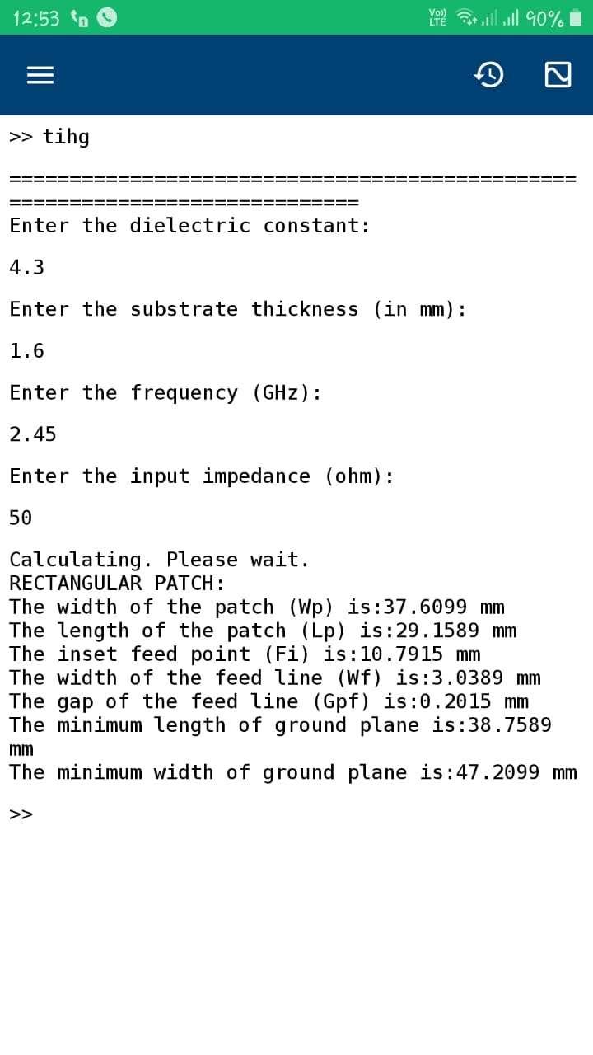 

Figure5.2: output 2

**OUTPUT DISPLAY:**

Design Rectangular Microstrip Antenna by Transmission Line Model Using MATLAB  
=============================================================================  
Enter the dielectric constant:

4.3

Enter the substrate thickness (in mm):

1.6

Enter the frequency (GHz):

2.45

Enter the input impedance (ohm):

50

Calculating. Please wait.  
RECTANGULAR PATCH:  
The width of the patch (Wp) is:37.6099 mm  
The length of the patch (Lp) is:29.1589 mm  
The inset feed point (Fi) is:10.7915 mm  
The width of the feed line (Wf) is:3.0389 mm  
The gap of the feed line (Gpf) is:0.2015 mm  
The minimum length of ground plane is:38.7589 mm  
The minimum width of ground plane is:47.2099 mm

**Advantages:**

Microstrip patch antenna has several advantages over conventional microwave antenna with one similarity of frequency range from 100 MHz to 100 GHz same in both type.

* Ease of Manufacturing
* Low weight
* Low profile
* Thin profile
* Required no cavity backing
* Linear and circulation polarization
* Capable of dual and triple frequency operation
* Feed lines and matching network can be fabricated simultaneously

**Limitation:**

* Low efficiency
* Low gain
* Large ohmic loss in the feed structure of arrays
* Low power handling capacity
* Excitation of surface waves
* Polarization purity is difficult to achieve
* Complex feed structures require high performance arrays

**Application**

The Microstrip patch antennas are well known for their performance and their robust design, fabrication and their extent usage. The advantages of this Microstrip patch antenna are to overcome their de-merits such as easy to design, light weight etc., the applications are in the various fields such as in the medical applications, satellites and of course even in the military systems just like in the rockets, aircrafts missiles etc. the usage of the Microstrip antennas are spreading widely in all the fields and areas and now they are booming in the commercial aspects due to their low cost of the substrate material and the fabrication. It is also expected that due to the increasing usage of the patch antennas in the wide range this could take over the usage of the conventional antennas for the maximum applications. Microstrip patch antenna has several applications. Some of these applications are discussed as below:

**Mobile and satellite communication application:** Mobile communication requires small, low-cost, low profile antennas. Microstrip patch antenna meets all requirements and various types of microstrip antennas have been designed for use in mobile communication systems. In case of satellite communication circularly polarized radiation patterns are required and can be realized using either square or circular patch with one or two feed points.

**Global Positioning System applications**: Nowadays microstrip patch antennas with substrate having high permittivity sintered material are used for global positioning system. These antennas are circularly polarized, very compact and quite expensive due to its positioning. It is expected that millions of GPS receivers will be used by the general population for land vehicles, aircraft and maritime vessels to find there position accurately

**Radio Frequency Identification (RFID)**: RFID uses in different areas like mobile communication, logistics, manufacturing, transportation and health care . RFID system generally uses frequencies between 30 Hz and 5.8 GHz depending on its applications. Basically RFID system is a tag or transponder and a transceiver or reader.

**Worldwide Interoperability for Microwave Access (WiMax):** The IEEE 802.16 standerd is known as WiMax. It can reach upto 30 mile radius theoretically and data rate 70 Mbps. MPA generates three resonant modes at 2.7, 3.3 and 5.3 GHz and can, therefore, be used in WiMax compliant communication equipment.

**Radar Application:** Radar can be used for detecting moving targets such as people and vehicles. It demands a low profile, light weight antenna subsystem, the microstrip antennas are an ideal choice. The fabrication technology based on photolithography enables the bulk production of microstrip antenna with repeatable performance at a lower cost in a lesser time frame as compared to the conventional antennas.

**Rectenna Application:** Rectenna is a rectifying antenna, a special type of antenna that is used to directly convert microwave energy into DC power. Rectenna is a combination of four subsystems i.e. Antenna, ore rectification filter, rectifier, post rectification filter. in rectenna application, it is necessary to design antennas with very high directive characteristics to meet the demands of long-distance links. Since the aim is to use the rectenna to transfer DC power through wireless links for a long distance, this can only be accomplished by increasing the electrical size of the antenna.

**Telemedicine Application:** In telemedicine application antenna is operating at 2.45 GHz. Wearable microstrip antenna is suitable for Wireless Body Area Network (WBAN). The proposed antenna achieved a higher gain and front to back ratio compared to the other antennas, in addition to the semi directional radiation pattern which is preferred over the omni-directional pattern to overcome unnecessary radiation to the user's body and satisfies the requirement for on-body and off-body applications. A antenna having gain of 6.7 dB and a F/B ratio of 11.7 dB and resonates at 2.45GHz is suitable for telemedicine applications.

**Medicinal applications of patch:** It is found that in the treatment of malignant tumors the microwave energy is said to be the most effective way of inducing hyperthermia. The design of the particular radiator which is to be used for this purpose should posses light weight, easy in handling and to be rugged. Only the patch radiator fulfils these requirements. The initial designs for the Microstrip radiator for inducing hyperthermia was based on the printed dipoles and annular rings which were designed on S-band. And later on the design was based on the circular microstrip disk at L-band. There is a simple operation that goes on with the instrument; two coupled Microstrip lines are separated with a flexible separation which is used to measure the temperature inside the human body. A flexible patch applicator can be seen in the figure below which operates at 430 MHz.

**CHAPTER -6**

**Future Scope**

* Microstrip antenna have a tremendous application potential. Even now this antennas are designed and used in personal communication systems.
* Mobile satellite communication, direct broadcast satellite, global positioning system, wireless local area network, intelligent vehicle highway system, and also it is receiving attention for microwave therapy.
* Simulators are invaluable tools for microstrip patch antenna. Suitability of these tools depends upon the sophistication of the models used in them. Microstrip array antennas are actively considered for application, such as satellite communication systems, where thin profile and light weight are important, consideration. The present model can be extended for array of microstrip patch antenna. For this development some additional models will have to be developed. Many applications in communications and radar required dual frequency. The present work can be extended also for designing of dual frequency patch antenna.
* In this dissertation only flat microstrip antennas have been investigated. Curved shaped microstrip antenna may be investigated for using it in biomedical application. It may be tried in future to develop microstrip antenna using semiconductor substrate. Researchers may also try to design microstrip antenna with switchable operating band.

**Conclusion**

Simulation of a rectangular microstrip antenna in MATLAB has been presented. Antennas are successfully simulated to operate at specified frequencies with specified dielectrics were modelled and simulated. For specified antenna parameters, appropriate dimensions and parameters of the patch antenna are obtained with the aid of transmission line model. The input we give are dielectric constant, substrate thickness, frequency, input impedance.

The output we obtain are:

The width of the patch (Wp)   
The length of the patch (Lp)   
The inset feed point (Fi)   
The width of the feed line (Wf)

The gap of the feed line (Gpf)   
The minimum length of ground plane  
The minimum width of ground plane

**Reference**

[1]. Constantine A. Balanis.(1997) Antenna Theory, II Edition, Arizona State University.

[2]. Brookner, E.(1997) Radar Technology. Artech House.

[3]. Van Trees. (2002) H. Optimum Array Processing. New York, NY:Wiley& Sons, NY.

[4]. Hazdra, P., Polivka, M. and Sokol, V., 2005. Microwave antennas and circuits modeling using electromagnetic field simulator. Radioengineering-Prague-, 14(4), p.2.

[5]. Odeyemi, K.O, Akande, D.O and Ogunti, E.O (2011) “Matlab Based Teaching Tools for Microstrip Patch Antenna Design”. Journal of Telecommunications, Volume 7, Issue 2.

[6] <https://www.mathworks.com/help/antenna/ref/patchmicrostrip.html>

**Appendix**

**flowchart**

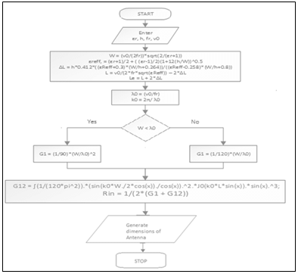

Figure 6.1: Flow chart for transmission line model

**PROGRAM CODE**

clc

format long

disp('Design Rectangular Microstrip Antenna Using MATLAB');

disp('============================================================================');

er=input('Enter the dielectric constant:');

h=input('Enter the substrate thickness (in mm):');

f=input('Enter the frequency (GHz):');

z=input('Enter the input impedance (ohm):');

disp('Calculating. Please wait.');

f=f*1e9;

%calculate the width

wid=(3e8/(sqrt((er+1)/2)*2*f))*1000; %in mm

%calculate the effective dielectric constant

e_eff=((er+1)/2)+ (((er-1)/2)* (1+((12*h)/wid))^-0.5);

%calculate the extension of length L

del_l=(((e_eff+0.3)*((wid/h)+0.264))/((e_eff-0.258)*((wid/h)+0.8)))*(0.412*h); %in mm

%calculate the effective length

l_eff=(3e8/(2*f*sqrt(e_eff)))*1000;

%calculate the actual length

L=l_eff-(2*del_l);

la=(3e8/f)*1000;

k=(2*pi)/la;

x=k*(wid);

i1=-2+cos(x)+(x*sinint(x))+(sin(x)/x);

g1=i1/(120*pi*pi); %Conductance

a=@(th)(((sin((x./2).*cos(th))./cos(th)).^2).*(besselj(0,(k.*L.*sin(th)))).*(sin(th)).^3);

a1=integral(a,0,pi);

g12=a1/(120*pi*pi); %in siemens

r_in=1/(2*(g1+g12)); %in ohms

inset=(L/pi)*(acos(sqrt(z/r_in))); %in mm

Lg_min=6*h+L;

Wg_min=6*h+wid;

B=60*pi*pi/(z*sqrt(er));

m1=2*B-1;

m=log(m1);

n1=B-1;

n=log(n1);

W=(2*h/pi)*(B-1-m+(((er-1)/(2*er))*(n+(0.39*0.61)/er)));

g = (3e8*4.65e-9)/(sqrt(2*e_eff)*f*10^-9);

disp('RECTANGULAR PATCH:')

disp(['The width of the patch (Wp) is:',num2str(wid),' mm'])

disp(['The length of the patch (Lp) is:',num2str(L),' mm'])

disp(['The inset feed point (Fi) is:',num2str(inset),' mm'])

disp(['The width of the feed line (Wf) is:',num2str(W),' mm'])

disp(['The gap of the feed line (Gpf) is:',num2str(g),' mm'])

disp(['The minimum length of ground plane is:',num2str(Lg_min),' mm'])

disp(['The minimum width of ground plane is:',num2str(Wg_min),' mm'])

**OUTPUT DISPLAY:**

Design Rectangular Microstrip Antenna by Transmission Line Model Using MATLAB  
=============================================================================  
Enter the dielectric constant:

4.3

Enter the substrate thickness (in mm):

1.6

Enter the frequency (GHz):

2.45

Enter the input impedance (ohm):

50

Calculating. Please wait.  
RECTANGULAR PATCH:  
The width of the patch (Wp) is:37.6099 mm  
The length of the patch (Lp) is:29.1589 mm  
The inset feed point (Fi) is:10.7915 mm  
The width of the feed line (Wf) is:3.0389 mm  
The gap of the feed line (Gpf) is:0.2015 mm  
The minimum length of ground plane is:38.7589 mm  
The minimum width of ground plane is:47.2099 mm